Contact:  Laurie Adelhardt  Public Relations Coordinator  Phone 410-705-3700  Fax 888-695-9308 | Headquarters:  53 Slama Road  Edgewater, MD 21037  Phone 410-956-5771  Fax 410-956-0161 | 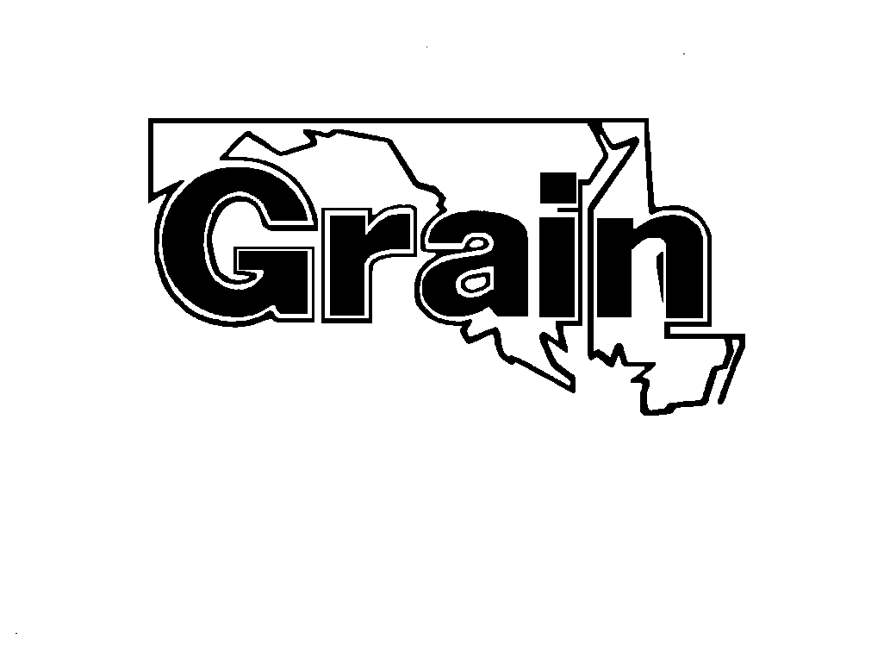  Maryland Grain  Producers Association  www.marylandgrain.com
PRESS RELEASE

FOR IMMEDIATE RELEASE

MGPUB Seeks Companies Ready to Install
A High-Blend Ethanol Terminal or E85 Retail Stations

ANNAPOLIS, MD, July 11, 2012. The Maryland Grain Producers Utilization Board (MGPUB) seeks companies interested in installing an E85 terminal or local E85 retail stations. MGPUB manages a Department of Energy Clean Cities Infrastructure Grant to develop E85 infrastructure in the Virginia, Maryland and Greater Washington region.
“Over the next few years, retailers will invest in infrastructure to meet the Renewable Fuel Standard, which will eventually exceed E10 and E15 blends,” said Marion Wilson, President of MGPUB. “Terminal and retail operators will be better prepared to meet this mandate by applying for funds now, which may not be available later.”

Funds are being offered for projects that expand the use of E85 to decrease the nation’s dependence on petroleum. Projects are sought that will contribute to a sustainable alternative fuel market with a potential for future growth in the absence of additional federal funding. Funding is available for an E85 terminal in Maryland and/or up to ten E85 retail sites located in Maryland, Virginia and/or the District of Columbia, with each partner providing at least 65% of the total project costs.
“The highest priority will be given to an E85 terminal in Maryland,” stated MGPUB Executive Director Lynne Hoot. “Second highest priority will be given to retail sites located along or near the I-95 corridor. Retail sites must be open to the public with construction complete by September 2013.”
Awards will be announced by August 31, 2012. MGPUB will work with selected partner(s) to complete federal forms as required. For application details, visit www.MarylandGrain.com. Please contact Jill Hamilton or Susan Susanke with questions at 703-322-4484 or at jhamilton@sesi-online.com.
###
The Maryland Grain Producers Utilization Board was established in 1991 to manage farmer checkoff investments to support promotion, education, and research resulting in greater utilization of grain. For more information, contact our office at 410-956-5771, visit www.marylandgrain.com and like us on Facebook at www.facebook.com/marylandgrain.

MARYLAND GRAIN PRODUCERS UTILIZATION BOARD
E85 GRANT APPLICATION

General Requirements: Selected projects must be shovel-ready. Construction is to be completed before September 2013. Funding is available for an E85 terminal in Maryland and/or up to ten E85 retail sites located in Maryland, Virginia and/or the District of Columbia. Participation is contingent upon final DOE approval. Partner(s) will be required to complete forms including a contract with MGPUB, environmental questionnaire and statement of work. Awards will be announced by August 31, 2012.

Funding: $200,000 in grant funds is available for a terminal and/or E85 retail locations. Each partner must provide at least a 65% cost-share. Cost share must be from non-federal sources. For example, if a project costs $100,000, the grant would pay $35,000 and the recipient would pay the remaining $65,000.

Funding Criteria:
- Highest priority will be given to an E85 terminal in Maryland.
- Second highest priority will be given to retail sites located along or near the I95 corridor.
- Retail sites must be open to the public.
- Each partner must provide at least 65% of the total project costs.

Applications: Applications should be submitted electronically to Jill Hamilton at jhamilton@sesi-online.com no later than midnight, August 10, 2012 and should include the following:
- Company contact information (name, address, phone, email);
- Type of facility (retail or terminal);
- Facility address;
- If retail, list local fleets willing to use E85;
- If retail, explain the entities marketing approach to increase E85 sales;
- Annual volume projections;
- Project description (for example, the project will modify an existing site by installing a new 25,000 gallon E85 storage tank, piping, electric, etc.);
- Estimated project costs;
- Projected start and completion dates;
- Status of permitting and design process; and
- List of relevant project funders, if any.

Questions: For questions, please contact Jill Hamilton or Susan Susanke at 703-322-4484 or at jhamilton@sesi-online.com.

